Infrared Alert System with RF Capability
Product Design Specification
Version 1.0
10/21/2013

VERSION HISTORY
[Provide information on how the development and distribution of the Product Design Specification, up to the final point of approval, was controlled and tracked. Use the table below to provide the version number, the author implementing the version, the date of the version, the name of the person approving the version, the date that particular version was approved, and a brief description of the reason for creating the revised version.]
Version  # | Implemented  By | Revision  Date | Approved  By | Approval  Date | Reason
1.0 | <Author name> | <mm/dd/yy> | <name> | <mm/dd/yy> | Initial Design Definition draft

NOTE TO READER
This is a PDS template obtained from:
http://www2.cdc.gov/cdcup/library/templates/default.htm
Template Name: Product Design
UP Template Version: 12/31/07

Format When Finished

TABLE OF CONTENTS
1 Introduction 5
1.1 Purpose of The Product Design Specification Document 5
2 General Overview and Design Guidelines/Approach 5
2.1 Assumptions / Constraints / Standards 5
3 Architecture Design 5
3.1 Logical View 5
3.2 Hardware Architecture 5
3.3 Software Architecture 5
3.4 Security Architecture 5
3.5 Communication Architecture 5
3.6 Performance 6
4 System Design 6
4.1 Use-Cases 6
4.2 Database Design 6
4.3 Data Conversions 6
4.4 Application Program Interfaces 6
4.5 User Interface Design 6
4.6 Performance 6
4.7 Section 508 Compliance 6
5 Product Design Specification Approval 7
Appendix A: References 8
Appendix B: Key Terms 9

Introduction

Purpose of The Product Design Specification Document
This document will be used for all specifications of the IR alert system currently in development. It will attempt to provide the readers as well as the engineering design team with the basis with which to develop the final product.

General Overview and Design Guidelines/Approach

Assumptions / Constraints / Standards
This project is to adhere to the ECE-411 standards put in place by Mark Faust and Andrew Greenberg. The constraints were defined as a unit that senses something, via sensor, which causes the actuation of something else. A microcontroller needs to be included for processing. The project is required to be complete in an 8 week period. It is up to the engineering team to develop a product that adheres to these constraints.

Approach
To satisfy design requirements, we propose a security system that will detect movement in a room and trip the unit. RF capability will be integrated into the system in order to communicate with other sensor units in the area to alert them of any intrusions. Each unit will be addressed to indicate which unit was tripped when the RF message is transmitted.

Architecture Design
Each individual security unit will consist of a sensor to detect movement in a room. An RF module to communicate to other security units. LEDs for alert notification. And a microprocessor for handling all information within the unit.

Logical View

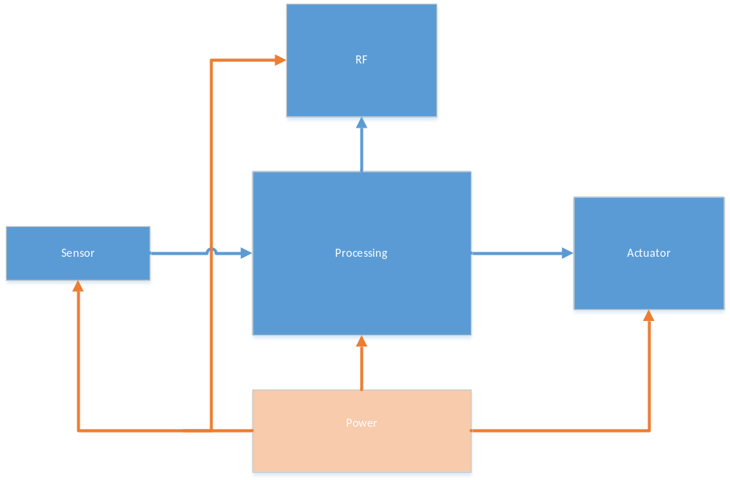
Figure 3.1 Security System at a Modular Level

Hardware Architecture

Sensor

RF
The RF section will be used to both transmit and receive information. The NRF24L01+ Transceiver module will be used. This unit will have a maximum operating speed of up to 2Mbps, GFSK modulation efficiency, anti-interference ability, and is particularly suitable for industrial control applications. All modulation and all RF tasks will be performed on this third party module.
A minimum of 6 I/O pins will be used to interface this RF module to the microprocessor.

LED Indication

There will be an LED indication system on each unit. This will be used to alert the end user of a sensor trip as well as indicate which security unit has tripped. A unique LED to represent each security unit will ensure the ability for more than one unit to trip at a time given the situation.

Processing

A microcontroller will be used to handle all information between modules. It will be designed to carry out functions dependent on the state of the sensor as well as any RF traffic. LED operation will also rely on commands sent from the microprocessor. RF functions include sending and receiving signals from the RF module as well as arming the RF module for select modes. A basic flow chart is attached below.

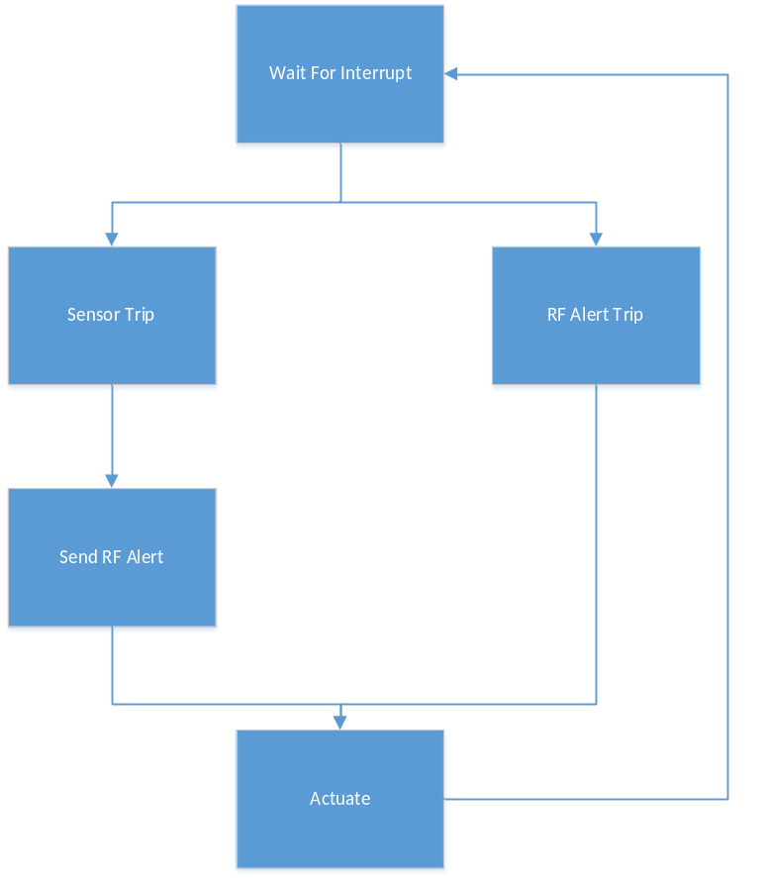
Figure 3.2.4 Flow Chart of Microprocessor Operation

Power

All modules included in each security unit have the ability to run in idle or low power modes. This will allow the possibility to explore batteries as the primary means of power.

Performance

Performance will depend on; The energy efficiency of each module. The range between each unit and RF strength. Sensitivity of the sensor in the chosen space. Optimization of microcontroller processes.

System Design

Use-Cases
[Insert any related project use cases or provide a reference to where they are stored.]

Database Design
[Insert any documents describing any necessary database design guidelines or provide a reference to where they are stored.]

Data Conversions
[Insert any documents describing any necessary data conversions or provide a reference to where they are stored.]

Application Program Interfaces
[Insert any application program interface documents or provide a reference to where they are stored.]

User Interface Design
[Insert any user interface design documents or provide a reference to where they are stored.]

Performance
[Insert any performance documents or provide a reference to where they are stored.]

Section 508 Compliance
[Insert any section 508 compliance related documents or provide a reference to where they are stored.]

Product Design Specification Approval

Signature: |  | Date:
Print Name:
Title:
Role:

Signature: |  | Date:
Print Name:
Title:
Role:

Signature: |  | Date:
Print Name:
Title:
Role:

Signature: |  | Date:
Print Name:
Title:
Role:

Signature: |  | Date:
Print Name:
Title:
Role:

Appendix A: References
[Insert the name, version number, description, and physical location of any documents referenced in this document. Add rows to the table as necessary.]
The following table summarizes the documents referenced in this document.
Document Name and Version | Description | Location
<Document Name and Version Number> | [Provide description of the document] | <URL or Network path where document is located>

Appendix B: Key Terms
[Insert terms and definitions used in this document. Add rows to the table as necessary. Follow the link below to for definitions of project management terms and acronyms used in this and other documents.
http://www2.cdc.gov/cdcup/library/other/help.htm
The following table provides definitions for terms relevant to this document.
Term | Definition
[Insert Term] | [Provide definition of the term used in this document.]
[Insert Term] | [Provide definition of the term used in this document.]
[Insert Term] | [Provide definition of the term used in this document.]

